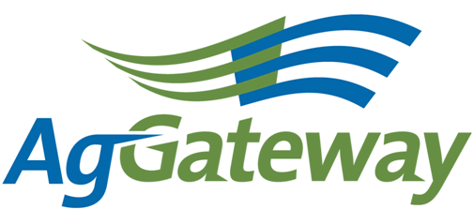
Need and

Membership & Communications

Meeting Agenda/Notes

2010-08-13(Friday)  11 :00 EST 60 minutes  866.507.7214 2778310#  http://www.aggateway.org/Default.aspx?tabid=564 | Contact: Chip Donahue Chair 217.971.5788 cell DonahueCharlesH@JohnDeere.com  Attendees  [ ] Dave Craft, SSI [x] Chip Donahue, John Deere [ ] Tim Piper, GROWMARK [x] Sarah Novak, AFIA [ ] Carl Bartenhagen, Monsanto [ ] Laura Wennemer, XS, Inc. [ ] Jerry Coupe, Wilbur-Ellis [ ] Marilyn Hunter, AgGateway [x] Marcia Rhodus, Monsanto [ ] Bruce Blitch, TKI [x] Lorie Gasso, CSC [ ] Doug Mills, Mosaic [x] Val Stopher, JR Simplot [ ] Brett Phipps, MFA [x] Marianne Embree, CFI [ ] Charissa Aclin, AgGateway [x] Rod Conner, AgGateway [x] Wendy Smith, AgGateway
Agenda
Time |  | Topic | Topic Leader | Desired Outcome | Notes
 |  | - Meeting Notes |  | Note-taker assigned
 |  | - AgGateway Antitrust Policy | C. Donahue | Agreement to abide by it | All consented
 | - Review Action Items |  | C. Donahue | Review of action items from last meeting | Wendy presented an overview of the Marketing Plan and requested comments back on the document by 8/20/10.  Project Documentation Policy communication is being worked on, more next month.
 | - 2010 – 2011 Tactical Marketing Plan, WS Goals/ Objectives |  | W. Smith | Wendy to provide high level view of draft marketing plan | Wendy discussed to Marketing Plan -she wants our feedback by Friday 8/20/10.  - Competitors, before reading the document, identify the organizations you think are AGW competitors.  - Target customers – how to best describe the target customer, how to convince the non customer to participate/join?  - Areas the M&C committee should help/lead?  - Squirrel theory – how to continuously create a new experience to keep membership fresh and attract new members  - Dynamic document – will be reviewed and updated to reflect market changes  Wendy wants help to get started by identifying a task team to provide recommendations to the larger group(s)
 | - Newsletter |  | C. Bartenhagen | Update | Carl is leaving AGW. We need someone to replace Carl to work on the newsletter with Charissa.  -identify articles for the newsletter  - write articles on new members  - help Charissa edit the newsletter
 | - Project Documentation Publication Policy to the M&C to determine |  | W. Smith, J. Coupe & C. Donahue | Determine how to communicate to the membership and use to market this policy to our membership  - Key contacts  - Newsletter  - Survey | In progress – Chip working on article, Wendy working on key contacts, Jerry will submit survey in September
 | - Additional Business |  | Committee | Status Update | None
 | - Commitments/ Action Items |  | C. Donahue | Agreement on commitments made (Action Items): | Review Marketing Plan and submit comments to Wendy by 8/20/10
 | - Upcoming Meetings |  | C. Donahue | Agreement on schedule | Next Meeting on September 10, 2010 at 10:00 am CST.

