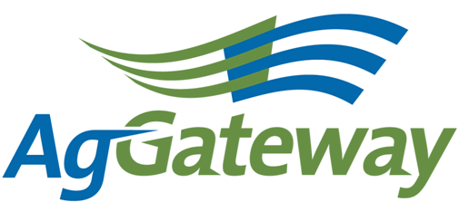Need and

Membership & Communications

Meeting Agenda/Notes

2010-07-9 (Wednesday)  11 :00 EST 60 minutes  866.507.7214 2778310#  http://www.aggateway.org/Default.aspx?tabid=564 | Contact: Chip Donahue Chair 217.971.5788 cell DonahueCharlesH@JohnDeere.com  Attendees  [ ] Dave Craft, SSI [ ] Chip Donahue, John Deere [ ] Tim Piper, GROWMARK [ ] Sarah Novak, AFIA [ ] Carl Bartenhagen, Monsanto [ ] Laura Wennemer, XS, Inc. [ ] Jerry Coupe, Wilbur-Ellis [ ] Marilyn Hunter, AgGateway [ ] Marcia Rhodus, Monsanto [ ] Bruce Blitch, TKI [ ] Lorie Gasso, CSC [ ] Doug Mills, Mosaic [ ] Val Stopher, JR Simplot [ ] Brett Phipps, MFA [ ] Marianne Embree, CFI [ ] Charissa Aclin, AgGateway [ ] Rod Conner, AgGateway [ ] Wendy Smith, AgGateway
Agenda
Time |  | Topic | Topic Leader | Desired Outcome | Notes
 |  | - Meeting Notes |  | Note-taker assigned
 |  | - AgGateway Antitrust Policy | C. Donahue | Agreement to abide by it
 | - Review Action Items |  | C. Donahue | Review of action items from last meeting
 | - 2010 – 2011 Tactical Marketing Plan, WS Goals/ Objectives |  | W. Smith | Update from CPP meeting – id action items
 | - Newsletter |  | C. Bartenhagen
 | - Project Documentation Publication Policy to the M&C to determine |  | W. Smith & C. Donahue | Determine how to communicate to the membership and use to market this policy to our membership
 | - Additional Business |  | Committee | Status Update
 | - Commitments/ Action Items |  | C. Donahue | Agreement on commitments made (Action Items):
 | - Upcoming Meetings |  | C. Donahue | Agreement on schedule | Next Meeting on August 13, 2010 at 10:00 am CST.

