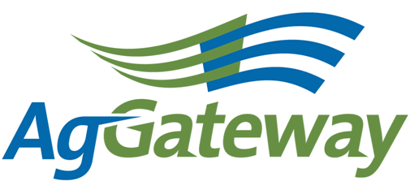Need and

Membership & Communications

Meeting Agenda/Notes

2010-07-9 (Wednesday)  11 :00 EST 60 minutes  866.507.7214 2778310#  http://www.aggateway.org/Default.aspx?tabid=564 | Contact: Chip Donahue Chair 217.971.5788 cell DonahueCharlesH@JohnDeere.com  Attendees  [X] Dave Craft, SSI [x] Chip Donahue, John Deere [ ] Tim Piper, GROWMARK [ ] Sarah Novak, AFIA [ ] Carl Bartenhagen, Monsanto [ ] Laura Wennemer, XS, Inc. [x] Jerry Coupe, Wilbur-Ellis [ ] Marilyn Hunter, AgGateway [ ] Marcia Rhodus, Monsanto [ ] Bruce Blitch, TKI [ ] Lorie Gasso, CSC [ ] Doug Mills, Mosaic [x] Val Stopher, JR Simplot [ ] Brett Phipps, MFA [ ] Marianne Embree, CFI [x] Charissa Aclin, AgGateway [ ] Rod Conner, AgGateway [x] Wendy Smith, AgGateway
Agenda
Time |  | Topic | Topic Leader | Desired Outcome | Notes
 |  | - Meeting Notes |  | Note-taker assigned
 |  | - AgGateway Antitrust Policy | C. Donahue | Agreement to abide by it | yes
 | - Review Action Items |  | C. Donahue | Review of action items from last meeting
 | - 2010 – 2011 Tactical Marketing Plan, WS Goals/ Objectives |  | W. Smith | Update from CCP meeting – id action items | Wendy will get a draft out to the M&C prior to the next meeting – wants some tactical ideas from the team on how to market AGW & AGIIS to members & non members
 | - Newsletter |  | C. Bartenhagen |  | Carl & Charissa are working on it and targeting to have it out July 12. August newsletter features would be helpful. New councils (Horticulture), policy updates, task forces
 | - Project Documentation Publication Policy to the M&C to determine |  | W. Smith & C. Donahue | Determine how to communicate to the membership and use to market this policy to our membership | Posting in the past not very efficient so what can we do to communicate the value of the Policy? ID key contact in each organization (Wendy). Who should we target the information to within the organizations? Face book page could be used, other social networking, how other orgs are using (Charissa). On line tools and face to face are useful. Maybe with the annual meeting – put a half page survey – how do you prefer to receive communication (Jerry). Put in the next news letters (Chip).
 | - Additional Business |  | Committee | Status Update | Chip talked about the USDA – RMA meeting and the need to work with them on using precision data for compliance reporting.
 | - Commitments/ Action Items |  | C. Donahue | Agreement on commitments made (Action Items): | Wendy to send marketing planning documents next week.  Jerry develops survey – target completion in September.  Chip to develop newsletter articles for August  Charissa to contact Sara Novak
 | - Upcoming Meetings |  | C. Donahue | Agreement on schedule | Next Meeting on August 13, 2010 at 10:00 am CST.

