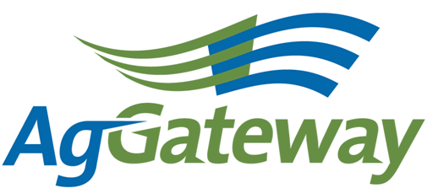Need and

Membership & Communications

Meeting Agenda/Notes

2010-02-12 (Friday)  10:00 AM CST 60 minutes  866.507.7214 2778310#  http://www.aggateway.org/Default.aspx?tabid=564 | Contact: Chip Donahue Chair 217.971.5788 cell DonahueCharlesH@JohnDeere.com  Attendees  [x] Dave Craft, SSI [x] Chip Donahue, John Deere [ ] Tim Piper, GROWMARK [ ] Sarah Novak, AFIA [x] Carl Bartenhagen, Monsanto [ ] Laura Wennemer, XS, Inc. [x] Jerry Coupe, Wilbur-Ellis [ ] Marilyn Hunter, AgGateway [x] Marcia Rhodus, Monsanto [ ] Bruce Blitch, TKI [ ] Lorie Gasso, CSC [ ] Doug Mills, Mosaic [x] Val Stopher, JR Simplot [ ] Brett Phipps, MFA [x] Marianne Embree, CFI [x] Charissa Aclin, AgGateway [x] Rod Conner, AgGateway
Agenda
Time | Topic |  | Topic Leader | Desired Outcome | Notes
 | - Meeting Notes |  |  | Note-taker assigned
 | - AgGateway Antitrust Policy |  | C. Donahue | Agreement to abide by it | All
0:10 |  | - Review Action Items | C. Donahue | Review of action items from last meeting
 |  | - Newsletter | C. Bartenhagen | Finalize Feb Newsletter | Should go it out this week.
 |  | - Press Releases | C. Donahue | Identify any news items that might merit a press release  Assign Press Release Lead? | CCP  New article in AgProfessional March or April  Add a blurb under the news items on home page.  Other ideas.
 |  | - Style Sheet for New AGW tagline | D. Craft | Status update | Dave worked with JUMP to develop style sheet draft document including templates for Power Points, e mail and letterhead. The draft document is on the web site under AGW guidelines. Please review and comment to Dave as soon as possible. Need to decide how to communicate to members and where to place it on the AGW site for members to use. How to provide access to the logo and templates – suggest keeping the templates for Members only. Put the information in a Press area so media, etc. can access appropriate information and style guide. Charissa and Dave will work through it.
 |  | - Promoting AGW at industry shows | Rod Conner | Status Update | Feed industry has a purchasing and ingredient suppliers conference, in March. Joel Newman AFIA inviting members to visit the host room for coffee prior to the meeting to promote AGW. Evaluating process and being flexible based on the opportunity.
 |  | - Strategic Objective #4 M&C Support | C. Donahue | Identify actions the M&C committee can take or initiate to support | Delayed until EVP on board.
 |  | - M&C Vice Chair, Liaisons | C. Donahue | Status Update | Still looking for a volunteer to be Vice Chair for this committee.
 |  | - Additional Business | Committee |  | CCP meeting June 15 – 17 in Indianapolis. CCP will schedule a time for M&C then we will decide whether to meet. We can review the marketing plan with the new EVP at the meeting.
0:10 |  | - Commitments/ Action Items | C. Donahue | Agreement on commitments made (Action Items):  - Style Sheet review Dave  - Newsletter update Charissa  - Newsletter Calendar Charissa  - CCP Meeting Update  - Annual Conference Update
 |  | - Upcoming Meetings | C. Donahue | Agreement on schedule | Next Meeting on March 12, 2010 at 10:00 am CST.

