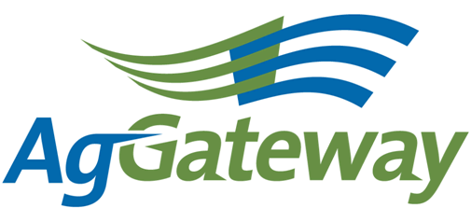 Communications Committee Minutes
2014-12-11  2:00 pm ET  877-301-8554 |  |  |  | Contact: Committee Chair Andriana Majarian 559 492 5510 andriana@agrian.com  Committee Vice Chair Kristin Nottingham  Attendees  [X ] Andriana Majarian* (Agrian – Chair) [ ] Nancy Appelquist *(Entira)= [ ] Dawn Ellis* (WinField – seed)= [ ] Natasha Lilly* (Effingham Equity)= [X] Brandon Olstad* (Claas)= [ ] Victoria Peoples*(Bayer – CPC) [ X] Susan Ruland *(AgGateway) [ ] Dave Craft* (SSI - AR) [ ] Sarah Novak (AFIA)= [ X] Kristin Nottingham* (SSI - AR) [ ] Melinda Giesler* (Fertilizer Institute) (*Voting companies/** alternates)
Topic |  | Topic Leader |  |  |  | Notes
- Meeting Minutes |  | Andriana Majarian
- Antitrust Guidelines |  | Andriana Majarian
- Approval of Prior Meeting Minutes from 11/12/14 |  | Andriana Majarian |  |  | Kristin approved and Brandon seconded the approval of the minutes.
- Review Action Items from last meeting |  | Andriana Majarian
- Newsletter Planning – January/February |  |  |  |  | AgGateway Newsletter Articles  Due Date: Tuesday, January 13  Title/Subject Author  eConnectivity Matters Wendy Smith  New Member Articles Natasha Lilly  AGIIS, Feb. 15 Deadline Josh Wall  AgGateway In The News Andriana Majarian  Leadership Profile Randy Beard  Board of Directors Announcement Susan Ruland  AgGateway, Crystal Coding Standards Susan Ruland
- Other discussion items |  | Andriana Majarian |  |  | Management Meeting -
- New Business  Committee Assignments |  | Andriana Majarian |  |  | Committee Positions –  Chair – Kristin Nottingham  Vice Chair position – Open  Newsletter Editor – Andriana Majarian/Asst. Editor - Open  New Member Articles – Natasha Lilly  Leadership Profiles – Brandon Olstad
- New Ideas for the Committee |  | Dave Craft
- Upcoming Meetings |  |  |  |  | Next Meeting – Thursday, January 8

Active Action Items List as of 12/04/14
Accountable | Action | Status
 | Andriana to send an email to Member Services to request the list of board members. (wait for press release to be sent.)
 | Andriana to reach out to Nancy regarding Communications Committee Chair attending the management meeting.
 | Dave Craft to reach out to the membership committee regarding the new member packet, if they need assistance, condensing the new member communications.

